Cloudflare Worker Deployment – Mailing Worker

Lab Title | Cloudflare Worker Deployment – Mailing Worker
Date | 8 / May / 2026
Environment Required | Cloudflare GUI Console Only
Resource Required | A Domain
Account Type | Root
Purpose | For document down the Cloudflare Worker deployment

Note:
This documentation covers only the Worker Deployment required for sending emails.

References:
Frontend Turnstile Submit Form Example (Star it to support)

Cloudflare Email Sender Worker Example (Star it to support)

- Create a Worker Application
Navigate to :[Cloudflare Home > Build > Workers & Pages]
Press button “Create Application”
Worker Configuration [Instance]
- [Template] Use a Template “Start with Hello World”
- [Naming] Worker Name : “enquiry” (Arbitrary Naming)
- Create
A new worker will appear in “Workers & Pages”
E.g.: enquiry.edward-demo.workers.dev is my one worker. enquiry is the naming, behind is domain.

Navigate to :[Cloudflare Home > Build > Workers & Pages > {Name of the Worker} ]
Press button in the tab “Bindings”
Press button “Add binding”
Worker Configuration [Binding]
- [Add a Binding] Use the “Email Service”
- [Naming] Binding Variable Name “SE_EMAIL”

- Security Phrase (Turnstile) Optional
Navigate to :[Cloudflare Home > Protect & Connect > Turnstile]
Press button “Add Widget”
Turnstile Widget Configuration [Instance]
- [Naming] Widget Name: “Enquiry_Token” (Arbitrary Naming)
- [Hostname Management] : “edward-demo.com”
- [Optional] : localhost (Unsecure but enable testing locally) – Remove when deployed to live.
Note: Enter your custom hostname or select from your existing sites on Cloudflare.
- [Widget Mode]: Managed (Default)
- [Pre-Clearance]: No (Default)
- Create
Key Extraction [Deployment Required] – Double Click on the Created Widget
- Extract Site Key: {0x4AAAAAADLJkdiGrjAzzz0x} Example
- Extract Secret Key: {0x4AAAAAAAAAAAAAAAv} Example
Navigate to :[Cloudflare Home > Build > Workers & Pages > {Name of the Worker} ]
Press button in the tab “Settings”
Under Variables and Secrets Section, press button “Add”
Worker Configuration [Settings : Add a Variable and Secrets]
- [Type] Type: Secret
- [Variable Name]: Variable Name: TURNSTILE_SEC_TOKEN (Arbitrary Naming)
- [Variable Value]: Value as “0x4AAAAAAAAAAAAAAAv” (Secret Key)
- Deploy

- Worker Program Code Deployment (Customize Accordingly) – No Explanation Here

- Email Routing — Destination Verification
Navigate to: [Cloudflare Home > Email > Email Routing]
Press tab "Routes"
Press tab "Destination addresses"
Press button "Add destination address"
Destination Address Configuration [Verification]
- [Address] Email Address: <Edward>@gmail.com (The inbox where contact emails will arrive)
- Press "Send" — Cloudflare emails a verification link to the address
- Open the verification email at the destination inbox → click "Verify email address"
- Return to Cloudflare → the address now shows status "Verified" with a green check
Note: there’s no needed to complete verification steps if the email address is the Cloudflare root address. I am using the root email address which same as the one that I used to register Cloudflare.

- Sender Domain Setup — DNS Records
Navigate to: [Cloudflare Home > {Your Domain} > Email > Email Routing]
Press tab "Settings"
Email Routing Configuration [Domain DNS]
- [Status] Confirm "Email Routing is enabled" toggle is ON
- [Records] Cloudflare auto-injects three MX records and one SPF TXT record. Press "Add records and enable" if prompted.
- [Verification] Wait ~30 seconds — the "DNS records configured" indicator should turn green
If you are using a Third-Party Components. E.g. (Zoho Email)
Note: DKIM is signed automatically by Cloudflare's outbound infrastructure — no manual DKIM record needed for send_email binding. If you are using third-party email infrastructures, DKIM is required to add-in manually.
Note: If you already use another email provider for incoming mail (Google Workspace, Microsoft 365), enabling Email Routing will replace their MX records. Configure Email Routing to forward to your existing inbox before enabling, or manage MX and DKIM manually. DKIM is the one most people missed

- Frontend Code Update
In your frontend application's contact form component, update two values:
Frontend Configuration [Endpoints]
- [Worker URL] Set the fetch target to the new Worker:
- https://enquiry.edward-demo.workers.dev/ (Example)

- [Turnstile Sitekey] Pass the Site Key (not Secret Key) when rendering the widget:
- 0x4AAAAAADLJkdiGrjAzzz0x (Example)
If you want to perform local test.
Pre-requisites: Turnstile widget's Hostname Management must include localhost (Step 2.3).
Local Testing Example
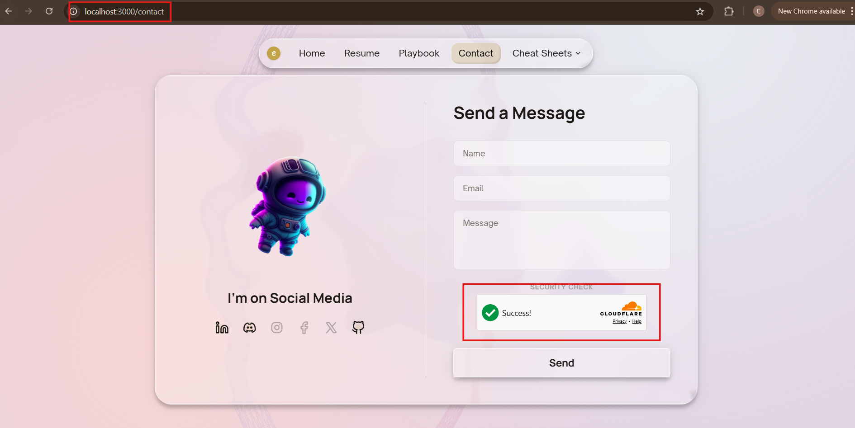

- Deploy to CDN
I am using AWS CloudFront as CDN, please refer to documentation “AWS_SCS_CloudFront”.

- Workers Deployment Hardening & Testing (Checklist)
# | Item | Where | Action
1 | Turnstile hostname list | Cloudflare > Turnstile > {Worker} | Remove localhost entry
2 | Worker Variable: Secret Type | Workers > {Worker}> Settings > Variables | Confirm TURNSTILE_SEC_TOKEN shows masked value (Secret type, not Text)
3 | ALLOWED_ORIGINS in Worker.js | Worker code | Optionally remove localhost entries
4 | Email Routing destination | Cloudflare > Email | Confirm destination address shows "Verified" status
5 | Worker URL match | Frontend code + Worker dashboard | Worker URL in fetch call exactly matches deployed Worker domain
6 | Live submission test | Production frontend | Submit real message, verify inbox delivery, delete the test email
7 | Logs review | Workers > enquiry > Logs | Confirm no recurring errors in Live Tail under normal load

